“DOG OF DEATH”: ECOLOGICAL THEORY CASE STUDY
(The Simpsons, Season 3, Episode 19)

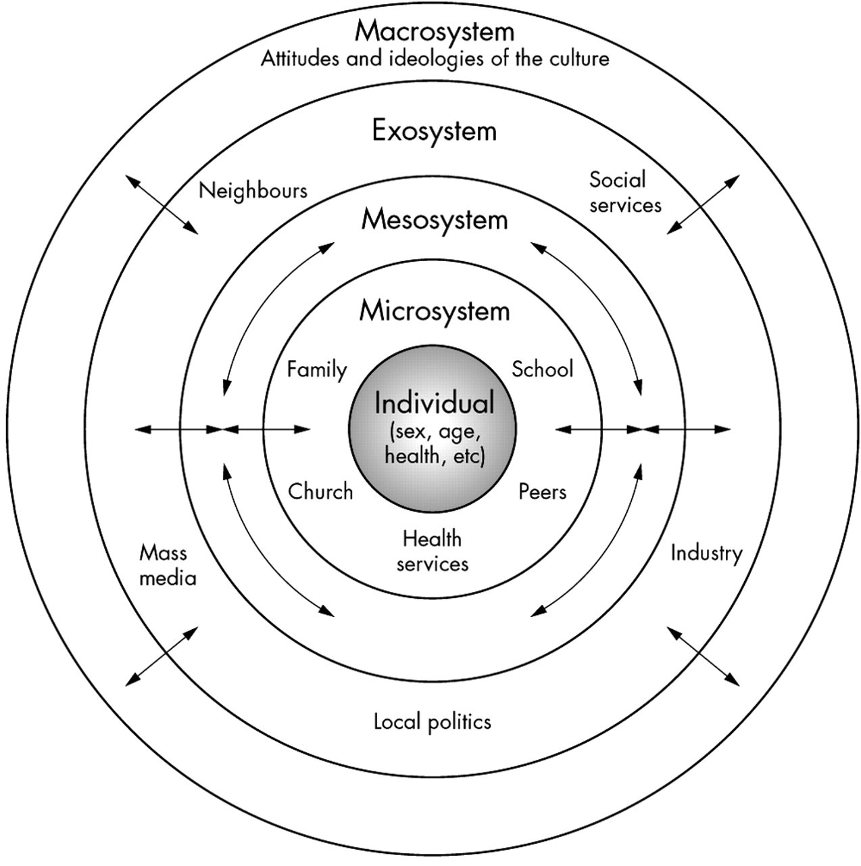

As you watch the video, identify Bart’s various systems using Bronfenbrenner’s Ecological Theory.
Individual
Microsystem
Mesosystem
Exosystem
Macrosystem

